บทที่ 7
การทดลองและผลการทดลอง

  - DES/3DES

เราได้ทำไดรเวอร์ให้สามารถทำงานได้ทั้ง des และ 3des โดยใน des สามารถทำได้ทั้งหมด 4 mode คือ ECB, CBC, OFB, CFB การทดสอบโปรแกรม เราได้ให้
Load Module
มีมอดูลโหลดเข้าไปจริง
ข้อความที่อยู่ไฟล์ h
โปรแกรมสำหรับเดโม
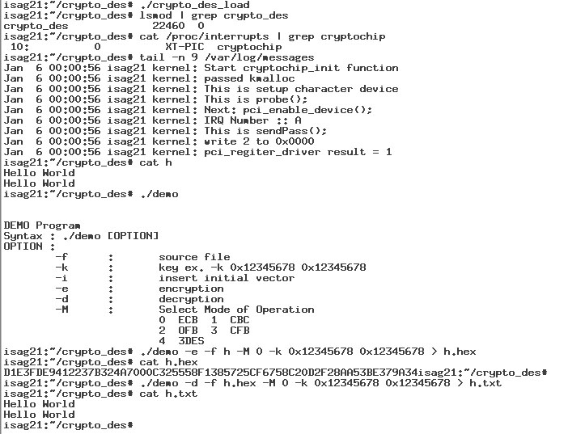
Cipher text ที่อยู่ในไฟล์
h.hex
ข้อความที่อยู่ไฟล์ h.txt
Decryption
Encryption
รูปที่ 7.1 แสดงภาพหน้าจอขณะรันโปรแกรมทดสอบ
<Encryption>
Jan 6 00:01:59 isag21 kernel: Open cryptochip
Jan 6 00:01:59 isag21 kernel: io_v_base: 32898
Jan 6 00:01:59 isag21 kernel: io_base: 4294377472
Jan 6 00:01:59 isag21 kernel: io_len: 65536
Jan 6 00:01:59 isag21 kernel: PASS_PCI: 1145525264
Jan 6 00:01:59 isag21 kernel: PCI Interrupts line 10
Jan 6 00:01:59 isag21 kernel: cryptochip_ioctl for 4004B50A command
Jan 6 00:01:59 isag21 kernel: cryptochip_ioctl before switch case
Jan 6 00:01:59 isag21 kernel: IOCTL : INSERT_KEY_L
Jan 6 00:01:59 isag21 kernel: INSERT_KEY_L : key_l = 12345678
Jan 6 00:01:59 isag21 kernel: cryptochip_ioctl for 4004B509 command
Jan 6 00:01:59 isag21 kernel: cryptochip_ioctl before switch case
Jan 6 00:01:59 isag21 kernel: IOCTL : INSERT_KEY_H
Jan 6 00:01:59 isag21 kernel: INSERT_KEY_H : key_h = 12345678
Jan 6 00:01:59 isag21 kernel: cryptochip_ioctl for 4004B508 command
Jan 6 00:01:59 isag21 kernel: cryptochip_ioctl before switch case
Jan 6 00:01:59 isag21 kernel: IOCTL : ASSIGN_DIRECTION
Jan 6 00:01:59 isag21 kernel: DIRECTION = 0
Jan 6 00:01:59 isag21 kernel: cryptochip_ioctl for 4004B50B command
Jan 6 00:01:59 isag21 kernel: cryptochip_ioctl before switch case
Jan 6 00:01:59 isag21 kernel: IOCTL : ASSIGN_MODE
Jan 6 00:01:59 isag21 kernel: ASSIGN_MODE : data = 0
Jan 6 00:01:59 isag21 kernel: modeop = 0
Jan 6 00:01:59 isag21 kernel: Input Source
Jan 6 00:01:59 isag21 kernel: Hello World
Jan 6 00:01:59 isag21 kernel: Hello World
Jan 6 00:01:59 isag21 kernel: 00000^F
Jan 6 00:01:59 isag21 kernel: cryptochip_write
Jan 6 00:01:59 isag21 kernel: count = 32
Jan 6 00:01:59 isag21 kernel: Mode of Operation is ECB
Jan 6 00:01:59 isag21 kernel: direction = 0
Jan 6 00:01:59 isag21 kernel: src1 = H
Jan 6 00:01:59 isag21 kernel: tmp1 = 00000048
Jan 6 00:01:59 isag21 kernel: ret1 = 48000000
Jan 6 00:01:59 isag21 kernel: src2 = e
Jan 6 00:01:59 isag21 kernel: tmp2 = 00000065
Jan 6 00:01:59 isag21 kernel: ret2 = 48650000
Jan 6 00:01:59 isag21 kernel: src3 = l
Jan 6 00:01:59 isag21 kernel: tmp3 = 0000006C
Jan 6 00:01:59 isag21 kernel: ret3 = 48656C00
Jan 6 00:01:59 isag21 kernel: src4 = l
Jan 6 00:01:59 isag21 kernel: tmp4 = 0000006C
Jan 6 00:01:59 isag21 kernel: ret4 = 48656C6C
...
Jan 6 00:01:59 isag21 kernel: src4 = ^F
Jan 6 00:01:59 isag21 kernel: tmp4 = 00000006
Jan 6 00:01:59 isag21 kernel: ret4 = 30303006
Jan 6 00:01:59 isag21 kernel: = 0
Jan 6 00:01:59 isag21 kernel: i = 1
Jan 6 00:01:59 isag21 kernel: x = 48656C6C
Jan 6 00:01:59 isag21 kernel: y = 6F20576F
Jan 6 00:01:59 isag21 kernel: Enable hardware to encrypt
Jan 6 00:01:59 isag21 kernel: Device has been finished its work
Jan 6 00:01:59 isag21 kernel: Cipher[0] = D1E3FDE9
Jan 6 00:01:59 isag21 kernel: Cipher[1] = 412237B3
...
Jan 6 00:01:59 isag21 kernel: cryptochip_read function
Jan 6 00:01:59 isag21 kernel: direction = 0
Jan 6 00:01:59 isag21 kernel: output = D1E3FDE9412237B324A7000C325558F1385725CF6758C20D2F28AA53BE379A34
Jan 6 00:01:59 isag21 kernel: kree(conv);
Jan 6 00:01:59 isag21 kernel: kree(output);
Jan 6 00:01:59 isag21 kernel: This is cryptochip_release();

เป็นคีย์ที่เป็นฐาน 16
สั่งให้พิมพ์ออกมาเป็นเลข 16
DIRECTION = 0 เป็น Encryption
Plain text
บอก Mode of Operation
ค่า ASCII ของตัว H
ค่าที่ Pad ลงไปเพื่อให้เต็ม block
Plain text block แรก
Cipher text block แรก
Cipher text ทั้งหมด
<Decryption>
Jan 6 00:02:25 isag21 kernel: Open cryptochip
... <เหมือนกับ Encryption>
Jan 6 00:02:25 isag21 kernel: IOCTL : ASSIGN_MODE
Jan 6 00:02:25 isag21 kernel: ASSIGN_MODE : data = 0
Jan 6 00:02:25 isag21 kernel: modeop = 0
Jan 6 00:02:25 isag21 kernel: Input Source
Jan 6 00:02:25 isag21 kernel: D1E3FDE9412237B324A7000C325558F1385725CF6758C20D2F28AA53BE379A34
Jan 6 00:02:25 isag21 kernel: cryptochip_write
Jan 6 00:02:25 isag21 kernel: count = 64
Jan 6 00:02:25 isag21 kernel: Mode of Operation is ECB
Jan 6 00:02:25 isag21 kernel: direction = 1
Jan 6 00:02:25 isag21 kernel: = 0
Jan 6 00:02:25 isag21 kernel: i = 1
Jan 6 00:02:25 isag21 kernel: x = D1E3FDE9
Jan 6 00:02:25 isag21 kernel: y = 412237B3
Jan 6 00:02:25 isag21 kernel: Enable hardware to encrypt
Jan 6 00:02:25 isag21 kernel: Device has been finished its work
Jan 6 00:02:25 isag21 kernel: Cipher[0] = 48656C6C
Jan 6 00:02:25 isag21 kernel: Cipher[1] = 6F20576F
...
Jan 6 00:02:25 isag21 kernel: cryptochip_read function
Jan 6 00:02:25 isag21 kernel: direction = 1
Jan 6 00:02:25 isag21 kernel: output = Hello World
Jan 6 00:02:25 isag21 kernel: Hello World
Jan 6 00:02:25 isag21 kernel: 00000^F
Jan 6 00:02:25 isag21 kernel: kree(conv);
Jan 6 00:02:25 isag21 kernel: kree(output);
Jan 6 00:02:25 isag21 kernel: This is cryptochip_release();
Cipher text ทั้งหมด
DIRECTION = 1 เป็น Decryption
Cipher text block แรก
Plain text block แรก
Plain text บวกกับpadding
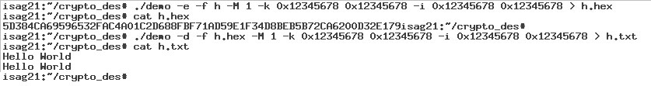
1 CBC Mode
Decryption
Encryption
รูปที่ 7.2 แสดงภาพผลการทดลองจากการรันโปรแกรมทดสอบ
<Encryption>
Jan 6 00:12:16 isag21 kernel: Open cryptochip
Jan 6 00:12:16 isag21 kernel: io_v_base: 32898
Jan 6 00:12:16 isag21 kernel: io_base: 4294377472
Jan 6 00:12:16 isag21 kernel: io_len: 65536
Jan 6 00:12:16 isag21 kernel: PASS_PCI: 1145525264
Jan 6 00:12:16 isag21 kernel: PCI Interrupts line 10
Jan 6 00:12:16 isag21 kernel: cryptochip_ioctl for 4004B50A command
Jan 6 00:12:16 isag21 kernel: cryptochip_ioctl before switch case
Jan 6 00:12:16 isag21 kernel: IOCTL : INSERT_KEY_L
Jan 6 00:12:16 isag21 kernel: INSERT_KEY_L : key_l = 12345678
Jan 6 00:12:16 isag21 kernel: cryptochip_ioctl for 4004B509 command
Jan 6 00:12:16 isag21 kernel: cryptochip_ioctl before switch case
Jan 6 00:12:16 isag21 kernel: IOCTL : INSERT_KEY_H
Jan 6 00:12:16 isag21 kernel: INSERT_KEY_H : key_h = 12345678
Jan 6 00:12:16 isag21 kernel: cryptochip_ioctl for 4004B510 command
Jan 6 00:12:16 isag21 kernel: cryptochip_ioctl before switch case
Jan 6 00:12:16 isag21 kernel: IOCTL : INSERT_IV_L
Jan 6 00:12:16 isag21 kernel: INSERT_IV_L : crypto_devices->iv_l = 12345678
Jan 6 00:12:16 isag21 kernel: cryptochip_ioctl for 4004B511 command
Jan 6 00:12:16 isag21 kernel: cryptochip_ioctl before switch case
Jan 6 00:12:16 isag21 kernel: IOCTL : INSERT_IV_H
Jan 6 00:12:16 isag21 kernel: INSERT_IV_H : crypto_devices->iv_h = 12345678
Jan 6 00:12:16 isag21 kernel: cryptochip_ioctl for 4004B508 command
Jan 6 00:12:16 isag21 kernel: cryptochip_ioctl before switch case
Jan 6 00:12:16 isag21 kernel: IOCTL : ASSIGN_DIRECTION
Jan 6 00:12:16 isag21 kernel: DIRECTION = 0
Jan 6 00:12:16 isag21 kernel: cryptochip_ioctl for 4004B50B command
Jan 6 00:12:16 isag21 kernel: cryptochip_ioctl before switch case
Jan 6 00:12:16 isag21 kernel: IOCTL : ASSIGN_MODE
Jan 6 00:12:16 isag21 kernel: ASSIGN_MODE : data = 1
Jan 6 00:12:16 isag21 kernel: modeop = 1
Jan 6 00:12:16 isag21 kernel: Input Source
Jan 6 00:12:16 isag21 kernel: Hello World
Jan 6 00:12:16 isag21 kernel: Hello World
Jan 6 00:12:16 isag21 kernel: 00000^F
Jan 6 00:12:16 isag21 kernel: cryptochip_write
Jan 6 00:12:16 isag21 kernel: count = 32
Jan 6 00:12:16 isag21 kernel: Mode of Operation is CBC
Jan 6 00:12:16 isag21 kernel: direction = 0
Jan 6 00:12:16 isag21 kernel: CBC Mode Encryption
Jan 6 00:12:16 isag21 kernel: src1 = H
Jan 6 00:12:16 isag21 kernel: tmp1 = 00000048
Jan 6 00:12:16 isag21 kernel: ret1 = 48000000
Jan 6 00:12:16 isag21 kernel: src2 = e
Jan 6 00:12:16 isag21 kernel: tmp2 = 00000065
Jan 6 00:12:16 isag21 kernel: ret2 = 48650000
เป็นคีย์ที่เป็นฐาน 16
สั่งให้พิมพ์ออกมาเป็นเลข 16
เป็น Initial Vector ที่เป็น
ฐาน 16 สั่งให้พิมพ์ออกมาเป็นเลข 16
บอก Mode of Operation
ค่า ASCII ของตัว H
Jan 6 00:12:16 isag21 kernel: src3 = l
Jan 6 00:12:16 isag21 kernel: tmp3 = 0000006C
Jan 6 00:12:16 isag21 kernel: ret3 = 48656C00
Jan 6 00:12:16 isag21 kernel: src4 = l
Jan 6 00:12:16 isag21 kernel: tmp4 = 0000006C
Jan 6 00:12:16 isag21 kernel: ret4 = 48656C6C
...
Jan 6 00:12:16 isag21 kernel: src4 = ^F
Jan 6 00:12:16 isag21 kernel: tmp4 = 00000006
Jan 6 00:12:16 isag21 kernel: ret4 = 30303006
Jan 6 00:12:16 isag21 kernel: XOR Expession
Jan 6 00:12:16 isag21 kernel: firstround = 1
Jan 6 00:12:16 isag21 kernel: conv XOR IV
Jan 6 00:12:16 isag21 kernel: conv[0] = 48656C6C
Jan 6 00:12:16 isag21 kernel: conv[1] = 6F20576F
Jan 6 00:12:16 isag21 kernel: Evaluted conv
Jan 6 00:12:16 isag21 kernel: conv[0] = 5A513A14
Jan 6 00:12:16 isag21 kernel: conv[1] = 7D140117
Jan 6 00:12:16 isag21 kernel: Enable hardware to encrypt
Jan 6 00:12:16 isag21 kernel: Device has been finished its work
Jan 6 00:12:16 isag21 kernel: Cipher[0] = 5D384CA6
Jan 6 00:12:16 isag21 kernel: Cipher[1] = 9596532F
Jan 6 00:12:16 isag21 kernel: XOR Expession
Jan 6 00:12:16 isag21 kernel: firstround = 0
Jan 6 00:12:16 isag21 kernel: conv XOR conv
Jan 6 00:12:16 isag21 kernel: conv[2] = 726C6420
Jan 6 00:12:16 isag21 kernel: conv[0] = 5D384CA6
Jan 6 00:12:16 isag21 kernel: conv[3] = 726C6420
Jan 6 00:12:16 isag21 kernel: conv[1] = 9596532F
Jan 6 00:12:16 isag21 kernel: Evaluted conv
Jan 6 00:12:16 isag21 kernel: conv[2] = 2F542886
Jan 6 00:12:16 isag21 kernel: conv[3] = 9FDE3643
Jan 6 00:12:16 isag21 kernel: Enable hardware to encrypt
Jan 6 00:12:16 isag21 kernel: Device has been finished its work
Jan 6 00:12:16 isag21 kernel: Cipher[2] = AC4A01C2
Jan 6 00:12:16 isag21 kernel: Cipher[3] = D688FBF7
...
Jan 6 00:12:16 isag21 kernel: cryptochip_read function
Jan 6 00:12:16 isag21 kernel: direction = 0
Jan 6 00:12:16 isag21 kernel: output = 5D384CA69596532FAC4A01C2D688FBF71AD59E1F34D8BEB5B72CA6200D32E179
Jan 6 00:12:16 isag21 kernel: kree(conv);
Jan 6 00:12:16 isag21 kernel: kree(output);
Jan 6 00:12:16 isag21 kernel: This is cryptochip_release();

ค่าที่ Pad ลงไปเพื่อให้เต็ม block
Plain text block ที่สอง มา XOR กับ cipher text block แรก
Plain text block แรก ที่ผ่านการ XOR กับ IV
Cipher text block แรก
Cipher text block ที่สอง
Plain text block ที่สอง ที่ผ่านการ XOR กับ cipher text block แรก
Cipher text ทั้งหมด
Plain text block แรก

<Decryption>
Jan 6 00:12:37 isag21 kernel: Open cryptochip
… <เหมือนกับตอน Encryption>
Jan 6 00:12:37 isag21 kernel: cryptochip_ioctl for 4004B50B command
Jan 6 00:12:37 isag21 kernel: cryptochip_ioctl before switch case
Jan 6 00:12:37 isag21 kernel: IOCTL : ASSIGN_MODE
Jan 6 00:12:37 isag21 kernel: ASSIGN_MODE : data = 1
Jan 6 00:12:37 isag21 kernel: modeop = 1
Jan 6 00:12:37 isag21 kernel: Input Source
Jan 6 00:12:37 isag21 kernel: 5D384CA69596532FAC4A01C2D688FBF71AD59E1F34D8BEB5B72CA6200D32E179
Jan 6 00:12:37 isag21 kernel: cryptochip_write
Jan 6 00:12:37 isag21 kernel: count = 64
Jan 6 00:12:37 isag21 kernel: Mode of Operation is CBC
Jan 6 00:12:37 isag21 kernel: direction = 1
Jan 6 00:12:37 isag21 kernel: CBC Mode Decryption
Jan 6 00:12:37 isag21 kernel: Text_H = 5D384CA6
Jan 6 00:12:37 isag21 kernel: Text_L = 9596532F
Jan 6 00:12:37 isag21 kernel: Enable hardware to decrypt
Jan 6 00:12:37 isag21 kernel: Device has been finished its work
Jan 6 00:12:37 isag21 kernel: firstround = 1
Jan 6 00:12:37 isag21 kernel: x = 5A513A14
Jan 6 00:12:37 isag21 kernel: x ^= 12345678 := 48656C6C
Jan 6 00:12:37 isag21 kernel: y = 7D140117
Jan 6 00:12:37 isag21 kernel: y ^= 12345678 := 6F20576F
Jan 6 00:12:37 isag21 kernel: cipher_high = 5D384CA6
Jan 6 00:12:37 isag21 kernel: cipher_low= 9596532F
Jan 6 00:12:37 isag21 kernel: Cipher[0] = 48656C6C
Jan 6 00:12:37 isag21 kernel: Cipher[1] = 6F20576F
Jan 6 00:12:37 isag21 kernel: Text_H = AC4A01C2
Jan 6 00:12:37 isag21 kernel: Text_L = D688FBF7
Jan 6 00:12:37 isag21 kernel: Enable hardware to decrypt
Jan 6 00:12:37 isag21 kernel: Device has been finished its work
Jan 6 00:12:37 isag21 kernel: firstround = 0
Jan 6 00:12:37 isag21 kernel: x = 2F542886
Jan 6 00:12:37 isag21 kernel: x ^= 5D384CA6 := 726C6420
Jan 6 00:12:37 isag21 kernel: y = 9FDE3643
Jan 6 00:12:37 isag21 kernel: y ^= 9596532F := 0A48656C
Jan 6 00:12:37 isag21 kernel: cipher_high = AC4A01C2
Jan 6 00:12:37 isag21 kernel: cipher_low= D688FBF7
Jan 6 00:12:37 isag21 kernel: Cipher[2] = 726C6420
Jan 6 00:12:37 isag21 kernel: Cipher[3] = 0A48656C
...
Jan 6 00:12:37 isag21 kernel: cryptochip_read function
Jan 6 00:12:37 isag21 kernel: direction = 1
Jan 6 00:12:37 isag21 kernel: output = Hello World
Jan 6 00:12:37 isag21 kernel: Hello World
Jan 6 00:12:37 isag21 kernel: 00000^F
Jan 6 00:12:37 isag21 kernel: kree(conv);
Jan 6 00:12:37 isag21 kernel: kree(output);
Jan 6 00:12:37 isag21 kernel: This is cryptochip_release();

Cipher text ทั้งหมด
DIRECTION = 1 เป็น Decryption
Cipher text block แรก
Cipher text block แรก นำมา XOR กับ IV
Plain text block แรก
Plain text block ที่สอง ที่ผ่านการ decrypt นำมา XOR กับ cipher text block แรก
Plain text block แรก
Plain text บวกกับpadding
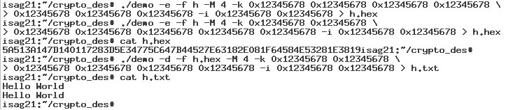
2. 3DES
รูปที่ 7.3 แสดงภาพหน้าจอตอนรันโปรแกรมทดสอบ
<Encryption>
Jan 6 07:05:11 isag21 kernel: Open cryptochip
Jan 6 07:05:11 isag21 kernel: io_v_base: 32898
Jan 6 07:05:11 isag21 kernel: io_base: 4294377472
Jan 6 07:05:11 isag21 kernel: io_len: 65536
Jan 6 07:05:11 isag21 kernel: PASS_PCI: 1145525264
Jan 6 07:05:11 isag21 kernel: PCI Interrupts line 10
Jan 6 07:05:11 isag21 kernel: cryptochip_ioctl for 4004B50A command
Jan 6 07:05:11 isag21 kernel: cryptochip_ioctl before switch case
Jan 6 07:05:11 isag21 kernel: IOCTL : INSERT_KEY_L
Jan 6 07:05:11 isag21 kernel: INSERT_KEY_L : key_l = 12345678
Jan 6 07:05:11 isag21 kernel: cryptochip_ioctl for 4004B509 command
Jan 6 07:05:11 isag21 kernel: cryptochip_ioctl before switch case
Jan 6 07:05:11 isag21 kernel: IOCTL : INSERT_KEY_H
Jan 6 07:05:11 isag21 kernel: INSERT_KEY_H : key_h = 12345678
Jan 6 07:05:11 isag21 kernel: cryptochip_ioctl for 4004B50D command
Jan 6 07:05:11 isag21 kernel: cryptochip_ioctl before switch case
Jan 6 07:05:11 isag21 kernel: IOCTL : INSERT_KEY_L
Jan 6 07:05:11 isag21 kernel: INSERT_KEY_L2 : key_L2 = 12345678
Jan 6 07:05:11 isag21 kernel: cryptochip_ioctl for 4004B50C command
Jan 6 07:05:11 isag21 kernel: cryptochip_ioctl before switch case
Jan 6 07:05:11 isag21 kernel: IOCTL : INSERT_KEY_H
Jan 6 07:05:11 isag21 kernel: INSERT_KEY_H2 : key_H2 = 12345678
Jan 6 07:05:11 isag21 kernel: cryptochip_ioctl for 4004B50F command
Jan 6 07:05:11 isag21 kernel: cryptochip_ioctl before switch case
Jan 6 07:05:11 isag21 kernel: IOCTL : INSERT_KEY_L
Jan 6 07:05:11 isag21 kernel: INSERT_KEY_L3 : key_L3 = 12345678
Jan 6 07:05:11 isag21 kernel: cryptochip_ioctl for 4004B50E command
Jan 6 07:05:11 isag21 kernel: cryptochip_ioctl before switch case
Jan 6 07:05:11 isag21 kernel: IOCTL : INSERT_KEY_H
Jan 6 07:05:11 isag21 kernel: INSERT_KEY_H3 : key_H3 = 12345678
Jan 6 07:05:11 isag21 kernel: cryptochip_ioctl for 4004B510 command
Jan 6 07:05:11 isag21 kernel: cryptochip_ioctl before switch case
Jan 6 07:05:11 isag21 kernel: IOCTL : INSERT_IV_L
Jan 6 07:05:11 isag21 kernel: INSERT_IV_L : crypto_devices->iv_l = 12345678
Jan 6 07:05:11 isag21 kernel: cryptochip_ioctl for 4004B511 command
Jan 6 07:05:11 isag21 kernel: cryptochip_ioctl before switch case
Jan 6 07:05:11 isag21 kernel: IOCTL : INSERT_IV_H
Jan 6 07:05:11 isag21 kernel: INSERT_IV_H : crypto_devices->iv_h = 12345678
Jan 6 07:05:11 isag21 kernel: cryptochip_ioctl for 4004B508 command
Jan 6 07:05:11 isag21 kernel: cryptochip_ioctl before switch case
Jan 6 07:05:11 isag21 kernel: IOCTL : ASSIGN_DIRECTION
Jan 6 07:05:11 isag21 kernel: DIRECTION = 0
Jan 6 07:05:11 isag21 kernel: cryptochip_ioctl for 4004B50B command
Jan 6 07:05:11 isag21 kernel: cryptochip_ioctl before switch case
Jan 6 07:05:11 isag21 kernel: IOCTL : ASSIGN_MODE
Jan 6 07:05:11 isag21 kernel: ASSIGN_MODE : data = 4
Jan 6 07:05:11 isag21 kernel: modeop = 4
Key แรก
DIRECTION = 1 เป็น Decryption
Key แรก
Key แรก
Initial Vector
Jan 6 07:05:11 isag21 kernel: Input Source
Jan 6 07:05:11 isag21 kernel: Hello World
Jan 6 07:05:11 isag21 kernel: Hello World
Jan 6 07:05:11 isag21 kernel: 00000^F
Jan 6 07:05:11 isag21 kernel: cryptochip_write
Jan 6 07:05:11 isag21 kernel: count = 32
Jan 6 07:05:11 isag21 kernel: 3DES CBC OUTTER
Jan 6 07:05:11 isag21 kernel: direction = 0
Jan 6 07:05:11 isag21 kernel: 3DES EDE with CBC Mode Encryption
Jan 6 07:05:11 isag21 kernel: src1 = H
Jan 6 07:05:11 isag21 kernel: tmp1 = 00000048
Jan 6 07:05:11 isag21 kernel: ret1 = 48000000
...
Jan 6 07:05:11 isag21 kernel: src4 = ^F
Jan 6 07:05:11 isag21 kernel: tmp4 = 00000006
Jan 6 07:05:11 isag21 kernel: ret4 = 30303006
Jan 6 07:05:11 isag21 kernel: XOR Expession
Jan 6 07:05:11 isag21 kernel: firstround = 1
Jan 6 07:05:11 isag21 kernel: conv XOR IV
Jan 6 07:05:11 isag21 kernel: conv[0] = 48656C6C
Jan 6 07:05:11 isag21 kernel: conv[1] = 6F20576F
Jan 6 07:05:11 isag21 kernel: Evaluted conv
Jan 6 07:05:11 isag21 kernel: conv[0] = 5A513A14
Jan 6 07:05:11 isag21 kernel: conv[1] = 7D140117
Jan 6 07:05:11 isag21 kernel: Encryption Step : Ede
Jan 6 07:05:11 isag21 kernel: Enable hardware to encrypt
Jan 6 07:05:11 isag21 kernel: Device has been finished its work
Jan 6 07:05:11 isag21 kernel: x[1] = 5D384CA6
Jan 6 07:05:11 isag21 kernel: y[1] = 9596532F
Jan 6 07:05:11 isag21 kernel: Encryption Step : eDe
Jan 6 07:05:11 isag21 kernel: Enable hardware to encrypt
Jan 6 07:05:11 isag21 kernel: Device has been finished its work
Jan 6 07:05:11 isag21 kernel: x[1] = 5A513A14
Jan 6 07:05:11 isag21 kernel: y[1] = 7D140117
Jan 6 07:05:11 isag21 kernel: Encryption Step : edE
Jan 6 07:05:11 isag21 kernel: Enable hardware to encrypt
Jan 6 07:05:11 isag21 kernel: Device has been finished its work
Jan 6 07:05:11 isag21 kernel: x[1] = 5D384CA6
Jan 6 07:05:11 isag21 kernel: y[1] = 9596532F
Jan 6 07:05:11 isag21 kernel: Cipher[0] = 5D384CA6
Jan 6 07:05:11 isag21 kernel: Cipher[1] = 9596532F
...
Jan 6 07:05:11 isag21 kernel: cryptochip_read function
Jan 6 07:05:11 isag21 kernel: direction = 0
Jan 6 07:05:11 isag21 kernel: output = 5D384CA69596532FAC4A01C2D688FBF71AD59E1F34D8BEB5B72CA6200D32E179
Jan 6 07:05:11 isag21 kernel: kree(conv);
Jan 6 07:05:11 isag21 kernel: kree(output);
Jan 6 07:05:11 isag21 kernel: This is cryptochip_release();
บอก Mode of Operation
Plain text บวกกับpadding
ค่าที่ Pad ลงไปเพื่อให้เต็ม block
ค่า ASCII ของตัว H
Plain text block แรก
Plain text block แรก ที่ผ่านการ XOR กับ IV
Cipher text block แรก
(Encryption)
Cipher text block แรก
(Decryption)
Cipher text block แรก
(Encryption)
Cipher text block แรก
เหมือนกัน
เหมือนกัน
Cipher text ทั้งหมด
<Decryption>
Jan 6 07:05:42 isag21 kernel: Open cryptochip
... <เหมือนEncryption>
Jan 6 07:05:42 isag21 kernel: IOCTL : ASSIGN_MODE
Jan 6 07:05:42 isag21 kernel: ASSIGN_MODE : data = 4
Jan 6 07:05:42 isag21 kernel: modeop = 4
Jan 6 07:05:42 isag21 kernel: Input Source
Jan 6 07:05:42 isag21 kernel: 5D384CA69596532FAC4A01C2D688FBF71AD59E1F34D8BEB5B72CA6200D32E179
Jan 6 07:05:42 isag21 kernel: cryptochip_write
Jan 6 07:05:42 isag21 kernel: count = 64
Jan 6 07:05:42 isag21 kernel: 3DES CBC OUTTER
Jan 6 07:05:42 isag21 kernel: direction = 1
Jan 6 07:05:42 isag21 kernel: 3DES DED with CBC Mode Decryption
Jan 6 07:05:42 isag21 kernel: Text_H = 5D384CA6
Jan 6 07:05:42 isag21 kernel: Text_L = 9596532F
Jan 6 07:05:42 isag21 kernel: Enable hardware to decrypt
Jan 6 07:05:42 isag21 kernel: Device has been finished its work
Jan 6 07:05:42 isag21 kernel: x[1] = 5A513A14
Jan 6 07:05:42 isag21 kernel: y[1] = 7D140117
Jan 6 07:05:42 isag21 kernel: Enable hardware to decrypt
Jan 6 07:05:42 isag21 kernel: Device has been finished its work
Jan 6 07:05:42 isag21 kernel: x[1] = 5D384CA6
Jan 6 07:05:42 isag21 kernel: y[1] = 9596532F
Jan 6 07:05:42 isag21 kernel: Enable hardware to decrypt
Jan 6 07:05:42 isag21 kernel: Device has been finished its work
Jan 6 07:05:42 isag21 kernel: x[1] = 5A513A14
Jan 6 07:05:42 isag21 kernel: y[1] = 7D140117
Jan 6 07:05:42 isag21 kernel: firstround = 1
Jan 6 07:05:42 isag21 kernel: x = 5A513A14
Jan 6 07:05:42 isag21 kernel: x ^= 12345678 := 48656C6C
Jan 6 07:05:42 isag21 kernel: y = 7D140117
Jan 6 07:05:42 isag21 kernel: y ^= 12345678 := 6F20576F
Jan 6 07:05:42 isag21 kernel: cipher_high = 5D384CA6
Jan 6 07:05:42 isag21 kernel: cipher_low= 9596532F
Jan 6 07:05:42 isag21 kernel: Cipher[0] = 48656C6C
Jan 6 07:05:42 isag21 kernel: Cipher[1] = 6F20576F
...
Jan 6 07:05:42 isag21 kernel: cryptochip_read function
Jan 6 07:05:42 isag21 kernel: direction = 1
Jan 6 07:05:42 isag21 kernel: output = Hello World
Jan 6 07:05:42 isag21 kernel: Hello World
Jan 6 07:05:42 isag21 kernel: 00000^F
Jan 6 07:05:42 isag21 kernel: kree(conv);
Jan 6 07:05:42 isag21 kernel: kree(output);
Jan 6 07:05:42 isag21 kernel: This is cryptochip_release();
DIRECTION = 1 เป็น Decryption
Cipher text block แรก
Plain text block แรก
Plain text block ที่แรก ที่ผ่านการ decrypt นำมา XOR กับ IV
Plain text block แรก
(Decryption)
Plain text block แรก
(Encryption)
Plain text block แรก
(Decryption)
เหมือนกัน
เหมือนกัน
Plain text บวกกับpadding
Cipher text ทั้งหมด
7.2 SHA1
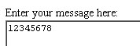
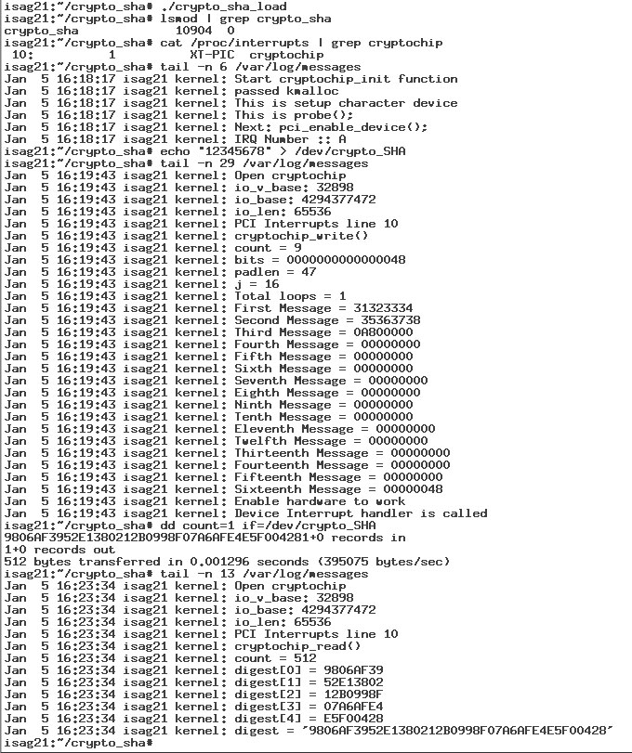
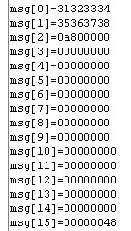
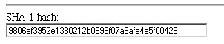
เราสามารถตรวจสอบการทำงานของไดรเวอร์ได้โดยดูจาก log file โดยเราได้เขียนให้ไดรเวอร์นั้นพิมพ์ค่าต่าง ๆ ออกมา แล้วนำผลลัพธ์ไปตรวจสอบกับผลลัพธ์ในเวบ (http://www.cs.eku.edu/faculty/styer/460/Encrypt/JS-SHA1.html)
Input
Load Module
Load Module
Messages
Digest

Padding ที่จะเติมเข้าไปด้านท้ายข้อความ
รูปที่ 7.4 แสดงผลลัพธ์ที่ได้จากการทำ SHA-1
รูปที่ 7.5 ภาพผลลัพธ์ที่ได้จากเวบไซต์ของการทำ SHA-1
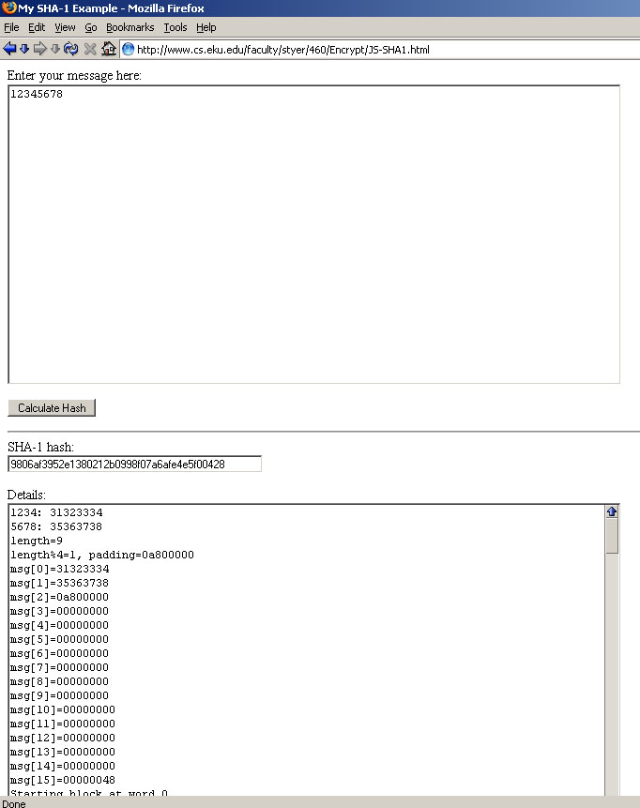
7.3 Pseudo Random Number Generator
เนื่องจากเราเลือกใช้ LFSR ดังนั้นเมื่อเรากรอกค่า 1 ลงไปในทุกบล็อกซึ่งมี 4 บล็อก ดังนั้นเราจึงสร้างไฟล์ขึ้นมาเก็บค่า 00000001000000010000000100000001 ลงในไฟล์ชื่อ one
จากนั้นเราใช้คำสั่ง cat เพื่อส่งค่าในไฟล์เข้าไดรเวอร์ และใช้คำสั่ง dd เพื่อให้เกิดการทำงานของฟังก์ชัน read ในไดรเวอร์ แล้วอ่านค่าใน log file ว่าค่าที่ได้ออกมานั้นตรงกันรึเปล่า
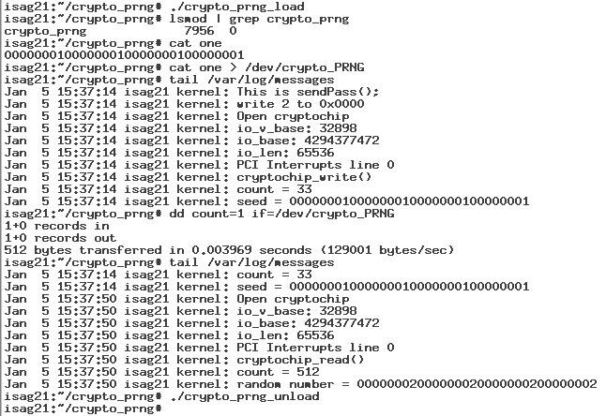
Load Module
มีมอดูลติดตั้งเข้าไปจริง
ค่าที่อยู่ในไฟล์ one
ค่าซีดที่ใส่เข้าไปในไดรเวอร์ เราใช้ printk พิมพ์ออกมาเป็นเลขฐานสิบหก
กระตุ้นให้ไดรเวอร์ทำฟังก์ชัน read
ค่าที่ได้จากการคำนวณของฮาร์ดแวร์
Remove Module
Load Module
มีมอดูลติดตั้งเข้าไปจริง
ค่าที่อยู่ในไฟล์ one
ค่าซีดที่ใส่เข้าไปในไดรเวอร์ เราใช้ printk พิมพ์ออกมาเป็นเลขฐานสิบหก
กระตุ้นให้ไดรเวอร์ทำฟังก์ชัน read
ค่าที่ได้จากการคำนวณของฮาร์ดแวร์
Remove Module
Load Module
มีมอดูลติดตั้งเข้าไปจริง
ค่าที่อยู่ในไฟล์ one
ค่าซีดที่ใส่เข้าไปในไดรเวอร์ เราใช้ printk พิมพ์ออกมาเป็นเลขฐานสิบหก
กระตุ้นให้ไดรเวอร์ทำฟังก์ชัน read
ค่าที่ได้จากการคำนวณของฮาร์ดแวร์
Remove Module
Load Module
มีมอดูลติดตั้งเข้าไปจริง
ค่าที่อยู่ในไฟล์ one
ค่าซีดที่ใส่เข้าไปในไดรเวอร์ เราใช้ printk พิมพ์ออกมาเป็นเลขฐานสิบหก
กระตุ้นให้ไดรเวอร์ทำฟังก์ชัน read
ค่าที่ได้จากการคำนวณของฮาร์ดแวร์
Remove Module

รูปที่ 7.6 แสดงผลลัพธ์ที่ได้จากการสร้างเลขสุ่มเทียมจากค่าตั้งต้นที่กำหนด
7.4 การทดสอบประสิทธิภาพการทำงาน
ในการทดสอบประสิทธิภาพการทำงานนั้น มีประเด็นที่ได้ทำการทดสอบคือความเร็วในการทำงาน โดยทำการทดสอบบนระบบที่มีส่วนประกอบดังนี้
- CPU : 166 MHz
- RAM : EDO 92 MB
- OS : Linux kernel 2.6.8-2-386
- PCI CARD : CryptoChip Application Prototype

การทดสอบการเข้าและถอดรหัสลับ
ในการทดสอบจะทำการเข้าและถอดรหัสลับกับไฟล์ที่มีขนาดต่าง ๆ และนำมาหาค่าเฉลี่ยเพื่อจะได้เป็นอัตราเร็วในการทำงาน การนับเวลารวมที่ใช้ในการทำงานนั้นจะใช้การบันทึกเวลาก่อนที่จะมีการงานส่วนของการเข้าและถอดรหัสลับ แล้วนำมาหักลบกับเวลาที่บันทึกหลังจากการทำงานเสร็จสิ้นลง ด้านล่างที่เห็นเป็นส่วนหนึ่งของโค้ดในโปรแกรมทดสอบ โค้ดนี้เป็นฟังก์ชันของการเข้ารหัสลับและฟังก์ชันถอดรหัสลับ จะว่ามีส่วนของการบันทึกเวลาอยู่ด้วย
โหมดของการทำงานนั้นเลือกเป็น CBC และวิธีที่ใช้เป็น 3DES
ฟังก์ชัน encryption()
void encryption(char *ctext, char *ptext, int ptext_s, int modeop)
{
int err;
int dirc = 0;
err = ioctl(fd, ASSIGN_DIRECTION, &dirc);
if (err != 0)
printf("err = %d\n", err);

err = ioctl(fd, ASSIGN_MODE, &modeop);
if (err != 0)
printf("err = %d\n", err);

/* Time count */
time_t startTime, endTime;
printf(“\nEncryption\n”);
/* Start Timer */
time(&startTime);
printf("\nStart Time : %ld\n", (long)startTime);

/* encryption */
write(fd, ptext, ptext_s);
read(fd, ctext, ptext_s*2);

/* Stop Timer */
time(&endTime);
printf("\nEnd Time : %ld\n", (long)endTime);
printf("\nElapsed Time : %ld seconds\n", (long) (endTime - startTime));
}

ฟังก์ชัน decryption()
void decryption(char *ctext, char *dtext, int dtext_s, int modeop)
{
int err;
int dirc = 1;
err = ioctl(fd, ASSIGN_DIRECTION, &dirc);
if (err != 0)
printf("err = %d\n", err);

err = ioctl(fd, ASSIGN_MODE, &modeop);
if (err != 0)
printf("err = %d\n", err);

/* Time count */
time_t startTime, endTime;
printf(“\nDecryption\n”);
/* Start Timer */
time(&startTime);
printf("\nStart Time : %ld\n", (long)startTime);

/* decryption */
write(fd, dtext, dtext_s);
read(fd, ctext, dtext_s/2);

/* Stop Timer */
time(&endTime);
printf("\nEnd Time : %ld\n", (long)endTime);
printf("\nElapsed Time : %ld seconds\n", (long) (endTime - startTime));
}
ตัวอย่างการทดสอบ

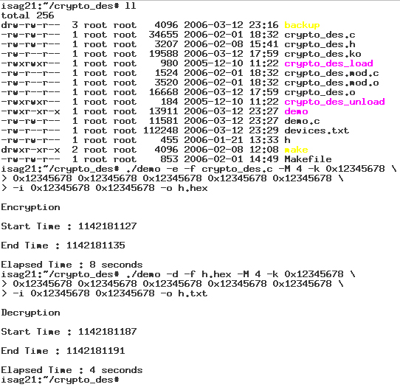
รูปที่ 7.7 ภาพตัวอย่างการทดสอบเข้าและถอดรหัสลับไฟล์

ผลการทดสอบกับไฟล์ขนาดต่าง ๆ ได้ผลลัพธ์ดังนี้
การทำงาน | ขนาดของไฟล์ (ไบต์) | ระยะเวลาที่ใช้ (วินาที)
เข้ารหัสลับ | 445 | 0
ถอดรหัสลับ | 912 | 0
เข้ารหัสลับ | 3207 | 1
ถอดรหัสลับ | 6416 | 1
เข้ารหัสลับ | 34655 | 8
ถอดรหัสลับ | 69312 | 4
ตารางที่ 7.1 ตารางแสดงผลการทดสอบอัตราเร็วในการเข้าและถอดรหัสลับ

จากผลการทดสอบที่ได้ทำให้เราสามารถนำมาหาค่าเฉลี่ยอัตราเร็วในการเข้าและถอดรหัสได้ โดยผลลัพธ์ที่ได้คือ
- อัตราเร็วในการเข้ารหัสลับคือประมาณ 3769 ไบต์ต่อวินาที
- อัตราเร็วในการถอดรหัสลับคือประมาณ 11872 ไบต์ต่อวินาที
ผลลัพธ์ที่ได้จากการทดสอบพบว่าอัตราเร็วในการเข้ารหัสลับนั้นช้ากว่าการถอดรหัสลับเพราะว่าการเข้ารหัสลับต้องใช้เวลาส่วนหนึ่งในการแปลงข้อมูลที่เข้ามาให้เป็นอยู่ในรูปแบบที่กำหนด ส่วนการถอดรหัสลับนั้นทำน้อยกว่าเพราะข้อมูลที่เข้ามาเป็นเลขฐานสิบหกอยู่แล้ว

